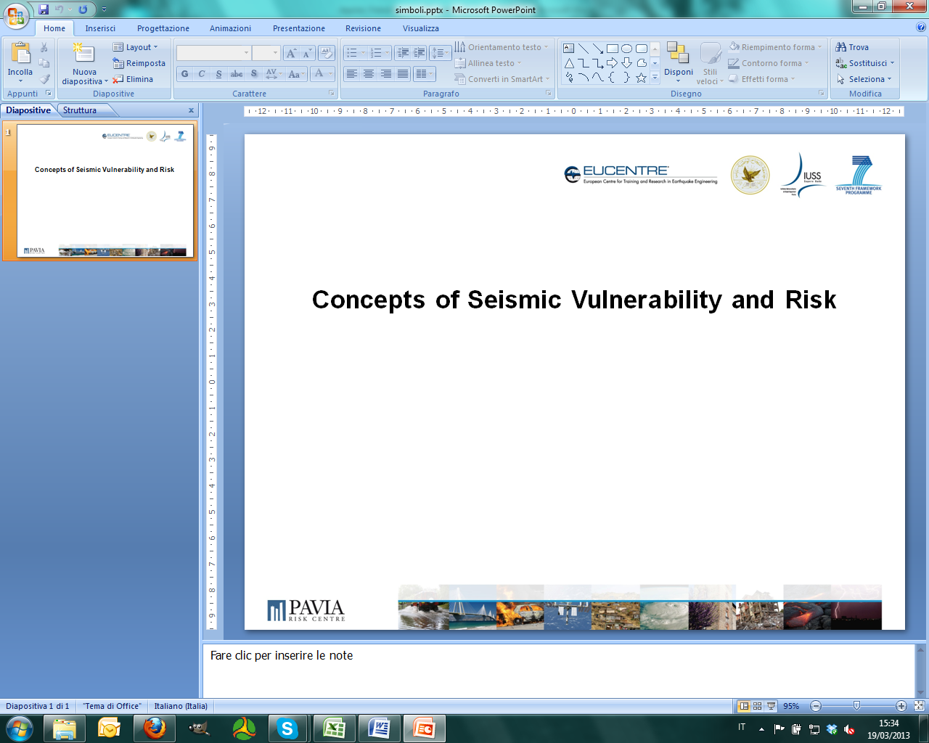

**SASPARM**

**Support Action for Strengthening Palestinian-administrated Areas**

**capabilities for seismic Risk Mitigation**

**Call ID FP7-INCO.2011-6.2**

**The SASPARM Project**

The project aims to reinforce the cooperation with Europe’s neighbours in the context of the European Research Area. The An-Najah National University (NNU) in the Palestinian-administered Areas (PS) is coordinating the project with the support of the European Centre for Training and Research in Earthquake Engineering (EUCENTRE) and the Institute for Advanced Study of Pavia (IUSS) in Italy.

The project activities are identified with the goal to create a research infrastructure and to develop and enhance international cooperation with PS in the field of scientific technology and capacity building, i.e. human resources, research policy, networks of researchers and research institutes. In an international framework the proposed activities will lead NNU to a fruitful cooperation with EU.

At national level an enhancement of capability will ensure PS to gain a centre prepared to respond to earthquake engineering and engineering seismology needs of the local community. The latter target will be pursued by enhancing the capability of NNU for training activity in the field of earthquake engineering. Furthermore, a higher visibility of NNU will encourage researchers to compete internationally in terms of scientific excellence (e.g., acquiring and participating in EU Framework projects related to seismic risk reductions) and increase their incentives to continue their research activities in PS.

**Course Objectives**

The course modules aim at increasing the role of NNU in the field of seismic risk mitigation in the national, regional and international panorama. Training modules and exchange of knowledge for NNU personnel, young students and practitioners will be fundamental ingredients for increasing the project visibility and improving the competitiveness of all partners. In addition, the reinforced research capacities of NNU will allow the organisation of effective training in local community on disaster risk reduction and emergency preparedness.

The SASPARM training modules have been organised taking direct advantage of the long experience of IUSS and EUCENTRE running international level Doctoral and Master Programmes in Earthquake Engineering and Engineering Seismology, with (Erasmus Mundus – MEEES Programme, www.meees.org) and without (Understanding and Managing Extremes, UME School, www.umeschool.it) mobility.

**Who can benefit from the courses?**

There are two types of courses: i) courses for practitioners and ii) courses for young researchers and students. The courses scheduled for young researchers and students are also open to practitioners.

**Course Modules for Practitioners**

**Module 1: Fundamentals of seismic analysis and seismic design**

**Lecturer**

Dr. Barbara Borzi

**Day 1:**

09:00 −10:30: Fundamentals of seismology

10:30 − 11:00: Coffee break

11:00 − 12:30: Seismic hazard in Palestine

12:30 – 14:30: Lunch break

14:30 − 16:00: Single Degree of Freedom System (SDOF)

16:00 − 16:30: Coffee break

16:30 − 19:00: Elastic Response Spectrum – Site effects EC8

**Day 2:**

09:00 – 10:30: Fundamental of ductility and Inelastic Response Spectra

10:30 − 11:00: Coffee break

11:00 − 12:30: Conceptual seismic design

12:30 − 14:30: Lunch break

14:30 − 16:00: Seismic Analysis

16:00 − 16:30: Coffee break

16:30 − 19:00: Capacity Design of Buildings

**Day 3:**

09:00 − 10:30: Assignment 1

10:30 − 11:00: Coffee break

11:00 − 13:00: Assignment 2

**Module 2: Seismic design according to codes used in Palestine (UBC 97, Jordanian Seismic Building Code)**

**Lecturer**

Dr. Jalal Al-Dabbeek

**Day 4:**

09:00 − 10:30: Seismic hazard according to code regulations

10:30 − 11:00: Coffee break

11:00 − 12:30: Seismic site effect according to code regulations

12:30 – 14:30: Lunch break

14:30 − 16:00: Seismic forces and building codes. Equivalent lateral force method according to code regulations

16:00 − 16:30: Coffee break

16:30 − 18:00: General note about geotechnical and foundation, seismic design considerations

**Day 5:**

09:00 − 10:30: The influence of architectural and structural configuration on seismic performance of buildings

10:30 − 11:00: Coffee break

11:00 − 12:30: Application on the seismic vulnerability of Palestinian common buildings

12:30 – 14:30: Lunch break

14:30 − 16:00: Assignment 1

16:00 − 16:30: Coffee break

16:30 − 18:00: Assignment 2

**Day 6:**

09:00 − 10:30: Assignment 3

10:30 − 11:00: Coffee break

11:00 − 12:30: Assignment 4

12:30 – 14:30: Lunch break

14:30 − 16:00: Structural details

16:00 − 16:30: Coffee break

16:30 − 18:00: Special topics on earthquake engineering (seismic retrofit and upgrading fundamentals,..etc)

**Corse Modules for young researchers and students**

**Module 1: Fundamentals of seismic vulnerability and seismic risk**

**Lecturers**

Dr. Jalal Al-Dabbeek, Dr. Barbara Borzi, Dr. Paola Ceresa

**Day 1:**

09:30 − 10:30: Concepts of vulnerability

10:30 − 11:30: Mathematical definitions of vulnerability and risk

11:30 − 14:30: Application 1, Application 2, Application 3, Application 4, and Application 5

**Module 2: Fundamentals of structural dynamics**

**Lecturer**

Dr. Alessandro Dazio

**Day 1:**

09:00 − 10:30: Introduction. SDoF systems: Equation of motion and modelling

10:30 − 11:00: Coffee break

11:00 − 12:30: Free vibrations

12:30 − 14:30: Lunch break

14:30 − 16:00: Assignment 1

16:00 − 16:30: Coffee break

16:30 − 18:00: Assignment 1

**Day 2:**

09:00 − 10:30: Harmonic excitation

10:30 − 11:00: Coffee break

11:00 − 12:30: Transfer functions

12:30 − 14:30: Lunch break

14:30 − 16:00: Forced vibrations

16:00 − 16:30: Coffee break

16:30 − 18:00: Forced vibrations

**Day 3:**

09:00 − 10:30: Seismic excitation (Part 1)

10:30 − 11:00: Coffee break

11:00 − 12:30: Seismic excitation (Part 2)

12:30 − 14:30: Lunch break

14:30 − 16:00: Assignment 2

16:00 − 16:30: Coffee break

16:30 − 18:00: Assignment 2

**Day 4:**

09:00 − 10:30: MDoF systems: Equation of motion

10:30 − 11:00: Coffee break

11:00 − 12:30: Free vibrations

12:30 − 14:30: Lunch break

14:30 − 16:00: Damping

16:00 − 16:30: Coffee break

16:30 − 18:00: Forced vibrations

**Day 5:**

09:00 − 10:30: Seismic excitation (Part 1)

10:30 − 11:00: Coffee break

11:00 − 12:30: Seismic excitation (Part 2)

12:30 − 14:30: Lunch break

14:30 − 16:00: Assignment 3

16:00 − 16:30: Coffee break

16:30 − 18:00: Assignment 3

**Module 3 : Ground response analyses and near-surface site characterization**

**Lecturer**

Prof. Carlo G. Lai and Dr. Maria-Daphne Mangriotis

**Day 1**

09:00 − 10:30: Fundamentals of wave propagation (Part 1)

10:30 − 11:00: Coffee break

11:00 − 12:30: Fundamentals of wave propagation (Part 2)

12:30 − 14:30: Lunch break

14:30 − 16:00: Ground response analyses (Part 1)

16:00 − 16:30: Coffee break

16:30 − 18:30: Case study and exercising

**Day 2**

09:00 − 10:30: Ground response analyses (Part 2)

10:30 − 11:00: Coffee break

11:00 − 12:30: Near-surface site characterization using seismic methods (invasive techniques)

12:30 − 14:30: Lunch break

14:30 − 16:00: Near-surface site characterization using seismic methods (non-invasive techniques)

16:00 − 16:30: Coffee break

16:30 − 18:30: Review of Fourier analysis and discrete inverse theory

**Day 3**

09:00 − 10:30: Seismic prospecting using active SASW/MASW techniques (Part 1)

10:30 − 11:00: Coffee break

11:00 − 12:30: Seismic prospecting using active SASW/MASW techniques (Part 2)

12:30 − 14:30: Lunch break

14:30 − 15:30: Seismic prospecting using passive MASW, ReMi and H/V techniques

15:30 − 16:45: Case study using real and synthetic geophysical seismic data

**Module 4 : Basic of signal processing, design of a specimens, system acquisition**

**Lecturer**

Dr. Simone Peloso

**Day 1:**

09:00 − 10:30: Basic of Sensor and Transducers (Part 1)

10:30 − 11:00: Coffee break

11:00 − 12:30: Basic of Sensor and Transducers (Part 2)

12:30 − 14:30: Lunch break

14:30 − 16:00: Description of Actuation Systems (Part 1)

16:00 − 16:30: Coffee break

16:30 − 18:00: Description of Actuation Systems (Part 1)

**Day 2:**

09:00 − 10:30: Description of Actuation Systems (Part 2)

10:30 − 11:00: Coffee break

11:00 − 12:30: Analysis of Signal (Part 1)

12:30 − 14:30: Lunch break

14:30 − 16:00: Analysis of Signal (Part 2)

16:00 − 16:30: Coffee break

16:30 − 18:00: Analysis of Signal (Part 2)

**Day 3:**

09:00 − 10:30: Scaling Strategy (Part 1)

10:30 − 11:00: Coffee break

11:00 − 12:30: Scaling Strategy (Part 2)

12:30 − 14:30: Lunch break

14:30 − 16:00: Testing Strategy

16:00 − 16:30: Coffee break

16:30 − 18:00: Testing Strategy

The researchers of NNU with the support of Eucentre and IUSS will train students, also with the support of the new laboratory equipment, to understand the dynamic of structures. A comparison of experimental response of a specimen prepared by NNU personnel will be compared with the analytical responses computed, for example, with Matlab.

**Project Coordinator**

**Dr. Jalal Al Dabbeek**

An-Najah National University (NNU)

**Lecturers**

**Dr. Jalal Al Dabbeek**

An-Najah National University (NNU)

**Dr. Barbara Borzi**

European Centre for Training and Research in Earthquake Engineering (EUCENTRE)

**Prof. Carlo G. Lai**

University of Pavia, Department of Civil and Architectural Engineering

European Centre for Training and Research in Earthquake Engineering (EUCENTRE)

**Dr. Simone Peloso**

European Centre for Training and Research in Earthquake Engineering (EUCENTRE)

**Dr. Paola Ceresa**

UME School, Institute for Advanced Study of Pavia (IUSS)

**Dr. Alessandro Dazio**

UME School, Institute for Advanced Study of Pavia (IUSS)

**Dr. Maria-Daphne Mangriotis**

Heriot-Watt University

European Centre for Training and Research in Earthquake Engineering (EUCENTRE)

www.sasparm.ps

www.najah.edu

www.eucentre.it

www.iusspavia.it

www.umeschool.it