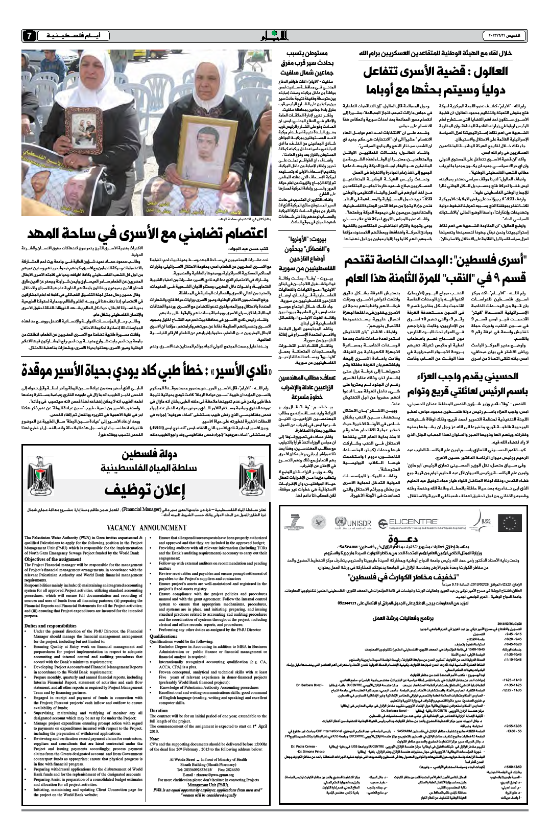

**Al Ayyam newspaper Thursday 21/Feb/2013**

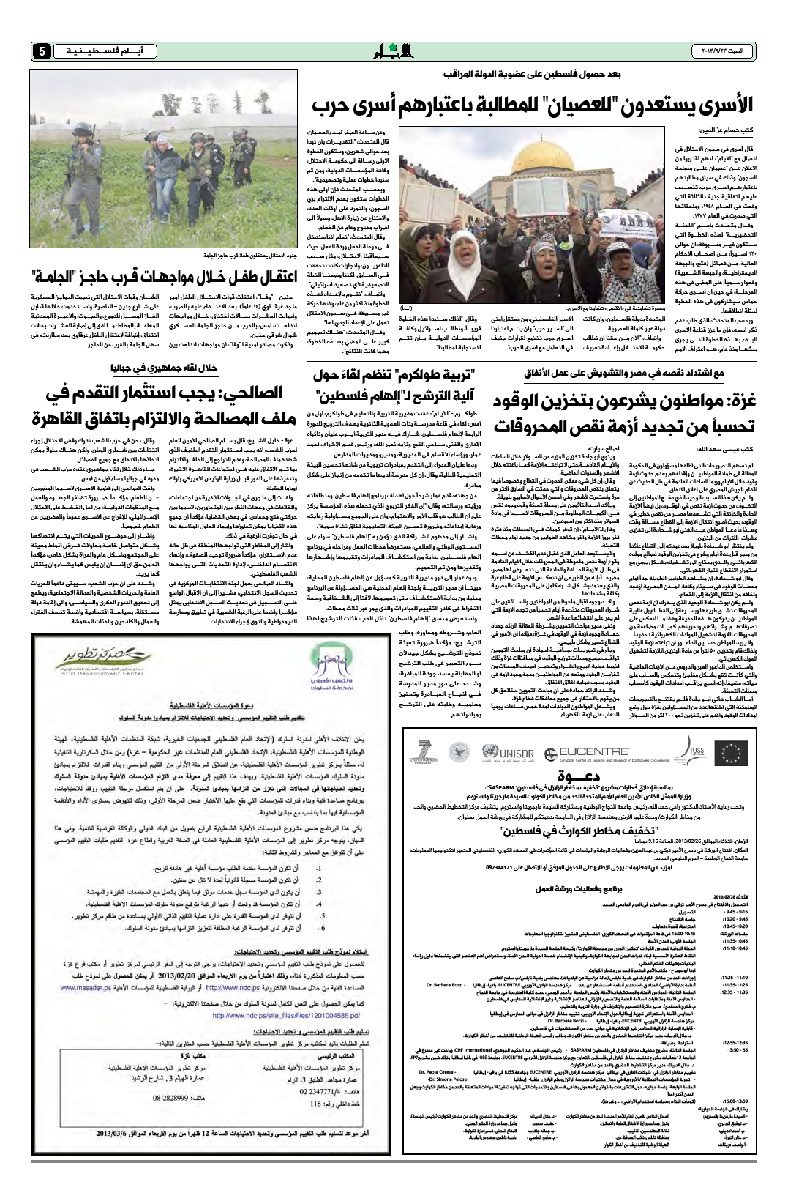

**Al Ayyam newspaper Sunday 23/Feb/2013**